At the end of each day, please check for this option when shutting down or restarting. This will finish any needed windows updates that have been applied.
Step 1: When shutting down, go to the bottom left corner of the screen and click on the windows icon.
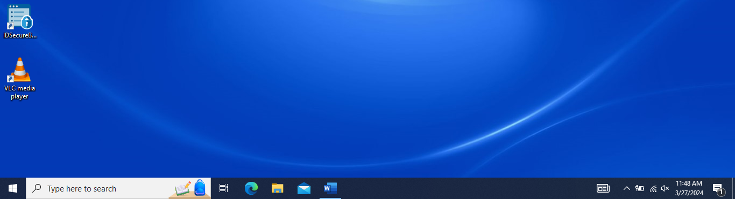
Step 2: Click on the power icon where you will notice two “new” or “different” options when choosing to shut down.
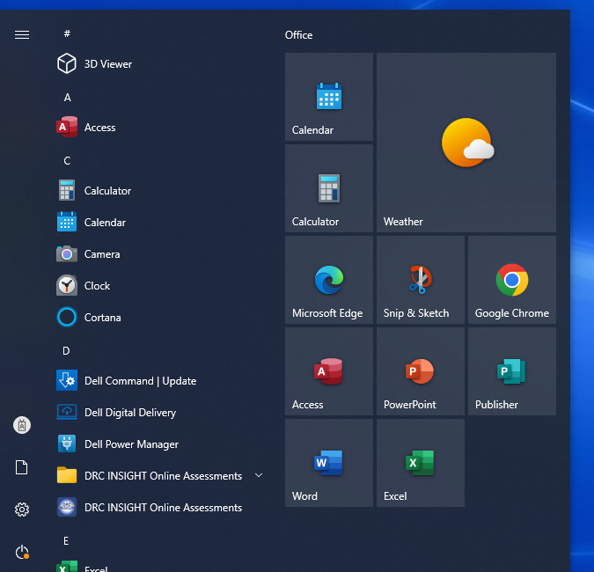
Step 3: If you are prompted with “Update and shut down” or “Update and restart,” please go ahead and choose one of those two options. This will finish the windows update and help your computer run more efficiently.
